NAME:SHREYASH PANAGE

ROLL NO:58

BRANCH:AIDS

**PRACTICAL NO 05-**

**AIM:Displaying data from multiple tables**

# 1 List the employees who are working in the Boston Location

SELECT e.Employee_Id, e.Last_Name, d.Name AS Department, l.Regional_Group

FROM EMPLOYEE e

JOIN DEPARTMENT d ON e.Department_Id = d.Department_Id

JOIN LOCATION l ON d.Location_Id = l.Location_Id

WHERE l.Regional_Group = 'Boston';

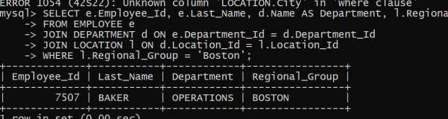

# 2 Display the name of the department of employees having salary more than 1600

SELECT d.Name AS DepartmentFROM EMPLOYEE e JOIN DEPARTMENT d ON e.Department_Id = d.Department_Id WHERE e.Salary > 1600;

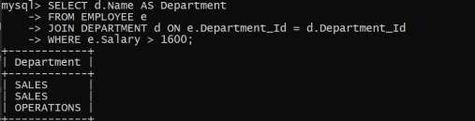

# 3. Give the complete information of the employees along with the name of their department and the name of their job

SELECT e.*, d.Name AS Department, j.FUNC AS Job

FROM EMPLOYEE e

JOIN DEPARTMENT d ON e.Department_Id = d.Department_Id

JOIN JOB j ON e.Job_Id = j.Job_Id;

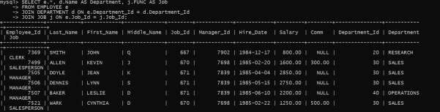

# 4. List the name of regional group whose employees got the highest commission

SELECT l.Regional_Group FROM LOCATION l

JOIN DEPARTMENT d ON l.Location_Id = d.Location_Id

JOIN EMPLOYEE e ON d.Department_Id = e.Department_Id

WHERE e.Comm = (SELECT MAX(Comm) FROM EMPLOYEE)

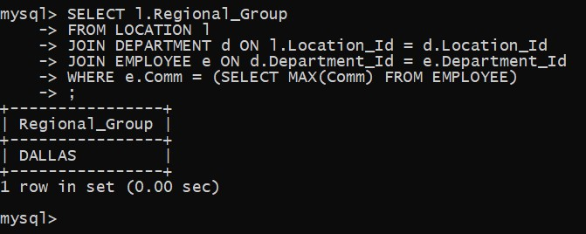

# 5. Display the name of employees along with the job function whose salary is greater than 2000

SELECT e.first_name ,e.last_name , j.FUNC FROM employee e JOIN job j ON e.job_id = j.job_id WHERE e.salary > 2000;

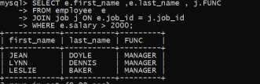

1. **count the number of employees who holds the position of clerck**

SELECT COUNT(*) as num_clerks

FROM EMPLOYEE e

INNER JOIN JOB j ON e.Job_Id = j.Job_Id

WHERE j.FUNC = 'CLERK';

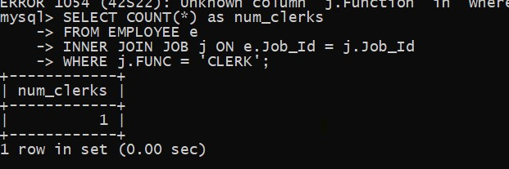

1. **Count the number of employees based on regional groups.**

SELECT L.Regional_Group, COUNT(*) as Num_Employees

FROM EMPLOYEE E

JOIN DEPARTMENT D ON E.Department_ID = D.Department_ID

JOIN LOCATION L ON D.Location_ID = L.Location_ID

GROUP BY L.Regional_Group;

